**PLC**

**Digital Output:**

to tell other device to do something (valve - tell valve to on n off)

4 points : PWM (control the speed of the blower / fan); can also use for on and off

4 more point : on and off

**Digital Input:**

other device tell PLC to do something - togel switch, receive the signal

8 points : to detect digital input , to tell other device.

**RS 232 (9 pins):**

mod bus / SCPI - skippy protocol. PLC tell Load bank to do some commance (on and off). Not mainly connected to load bank (for test station)

**Analog I/O (DB 15):**

4 voltage monitoring points, control cathode blower.

**7017**: Connected to RS 485 Port (for cell voltage)

8 voltage monitoring

**7018**: Connected to RS 485 Port (thermocouple)

8 temperature monitoring

**RJ 45 Port:**

Connect to PC , using LAN cable

**Power Cable:**

Black: connect to 0V

Red: 12-24V

PLC :

has to enter the integer value (cannot give decimal). Not support floating point.Try to insert not in the form of number.

**I/O Label**: Input

Input 1-8 is Digital Input. Only 1 to 8. Rename if needed.

Relay: Internal Switch, log

Internal (not physical)

Timer:

to count down. Purging valve (timer)

Counter:

If the user press the button 5 times, it will do something. (set to 4, counting things to do something).

Cust Func:

that we to program like turn on the replay or having the physical thing

Can be code and execute.

Special Bits:

Clock (build in clock,(if we want to get the data for ___ second), First Scan (initilize the PLC, run once when turn on)

**Modbus** (data trasfered, high and low signal). Different protocol using the same type of signal wave but different frequency and amplitude.

**SETIO** out1 ‘This will turn on the output out1

**CLRIO** out5 ‘This will turn off the output out5

**PMON** Interrupts and Pulse Measurement, measure the pulse width or frequency of a square-wave pulse-train arriving at its pulse.



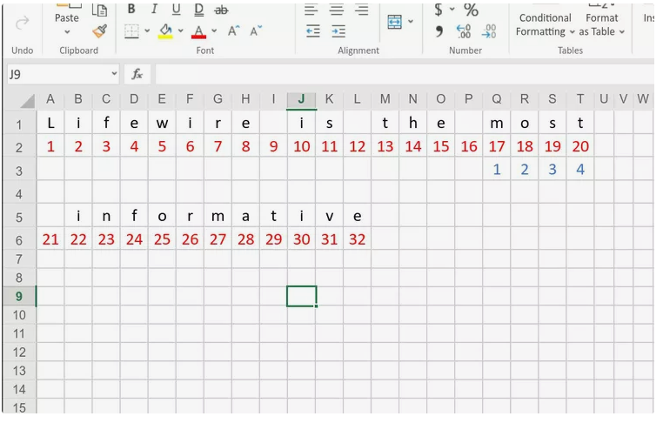

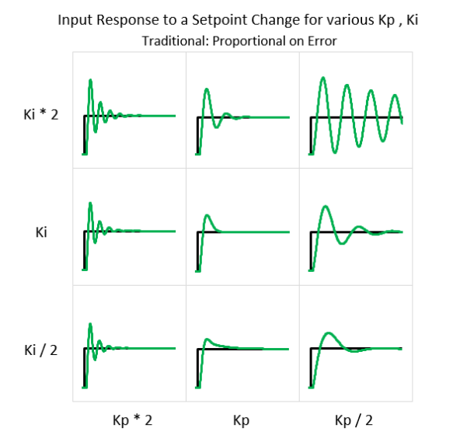

Kp is a proportional component. Kp is used to improve the transient response rise time and settling time of course. sensitivity of the process. If KP is too high, the system is responding quickly, but the first overshoot may be too big, resulting in a second overshoot the other way down, and so on. The system could become unstable.

Ki is an integral component. Ki works to improve steady-state response.

Kd is a derivative component. Kd is used to improve the transient response by way of predicting error will occur in the future.

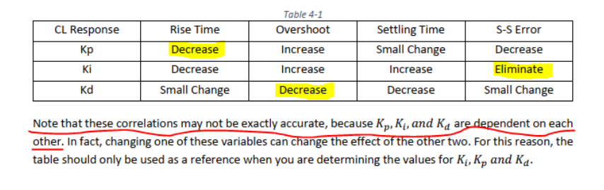

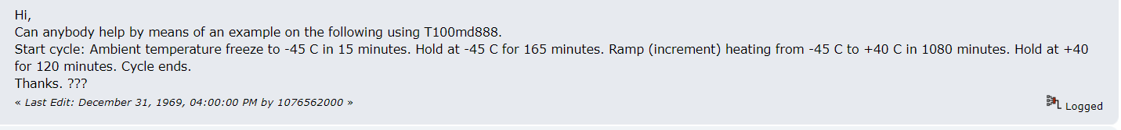

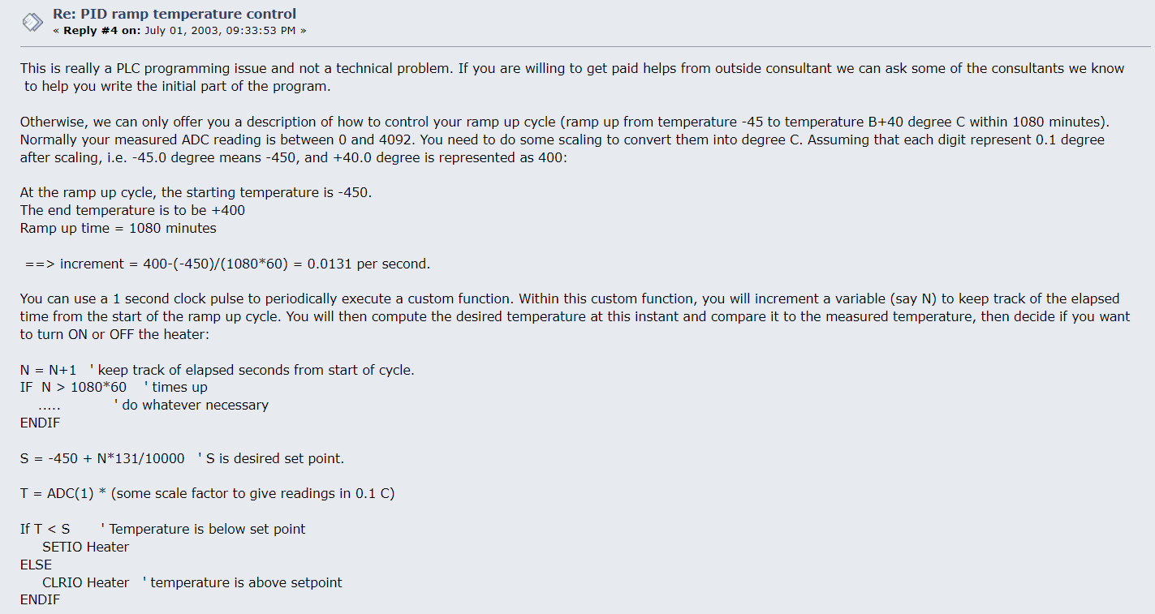

Trial on the PID Coding

'Proposed PID SETTING

'1. set the Setpoint, Kp (proportional gain), Ki(integral gain), Kd(derivative gain)

' Setpoint = 80.0 ; Kp=1.0 ; Ki=0.1 ; Kd=0.01

' dm[17] = B;

'2. Initialize variables for PID control

' integral_sum = 0 ; previous_error = 0

'3.Read current temperature

'current_temperature = A

'4. Calculate the error (difference between setpoint and current temperature)

'error = Setpoint - B

'5. Calculate the PID term

'Control_Output = (Kp * error) + (Ki * integral_sum) +(Kd * (error - previous_error))

'6. previous_error = error

'7. If Statement

'setlcd 0,0, CHR$(1)

'if Control_Output > 0

'setio SSR_A

'else

'Control_Output <= 0

'clrio SSR_A

'endif

**Gas Chromatography**

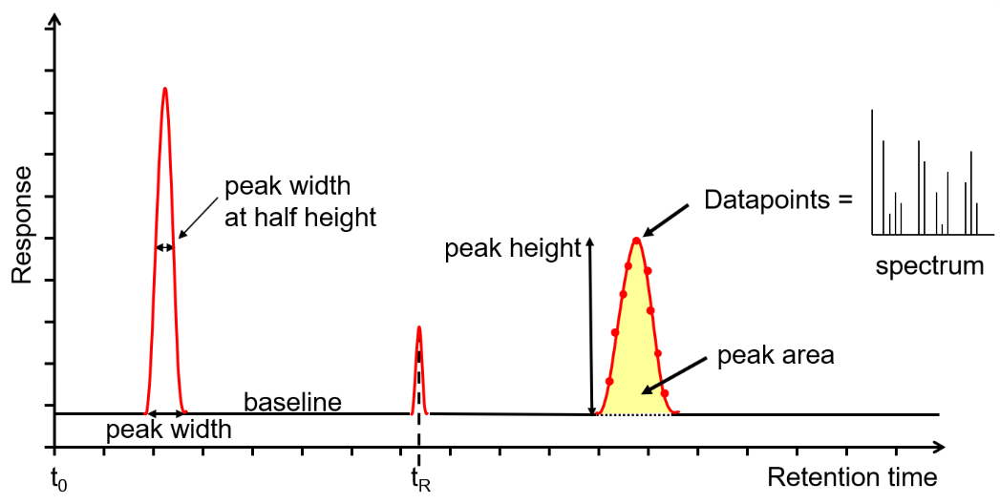

Retention time=taken from the time the sample was injected into the GC (t0) to the end of the GC run. Area that is used for quantitation as it is less affected by band broadening. Narrower, sharper peaks give better sensitivity (signal to noise ratio) and better resolution (peak separation). The peaks shown are Gaussian, however peak tailing (the right side of the peak is wider) indicates activity or a dead volume in the system, whereas a peak fronting (the left side of the peak is wider) indicates the column is overloaded. Accurate measurements are affected by the number of data points across a peak, with an ideal number being 15-25. Too few, makes the peak look like a child’s join-the-dots drawing, affecting peak area, resolution and, with GC-MS, deconvolution.

Transferring method:

For low concentration samples the whole vapour cloud is transferred into the analytical column by the carrier gas in what is known as [**splitless mode**](https://www.shsu.edu/~chm_tgc/primers/pdf/GC.pdf)**.** For high concentration samples only a portion of the sample is transferred to the analytical column in **split mode**, the remainder is flushed from the system through the split line to prevent overloading of the analytical column.

<https://www.shsu.edu/~chm_tgc/primers/pdf/GC.pdf>

**Splitless** method is use when we have a low concentration of the sample; **split** method is use when we have a high concentration sample.

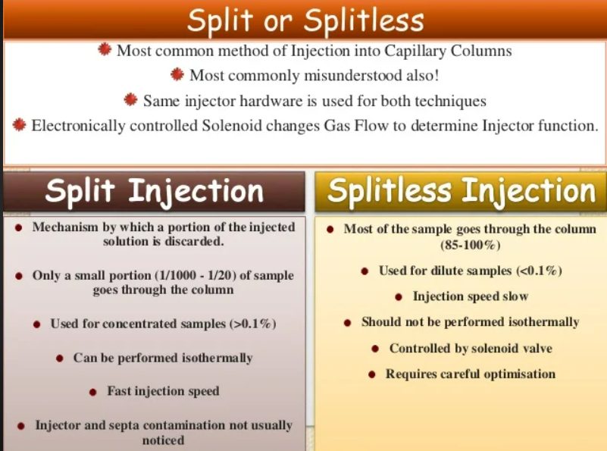

https://www.slideshare.net/GamalAbdulHamid/gas-chromatography-gc-51340065

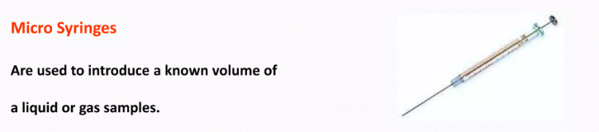

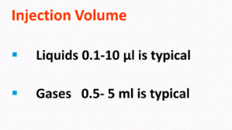

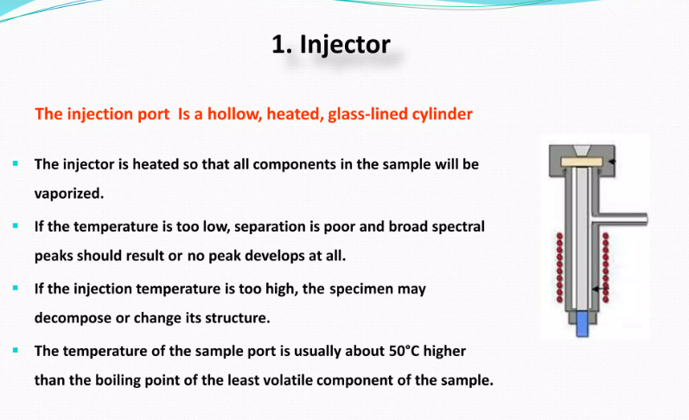

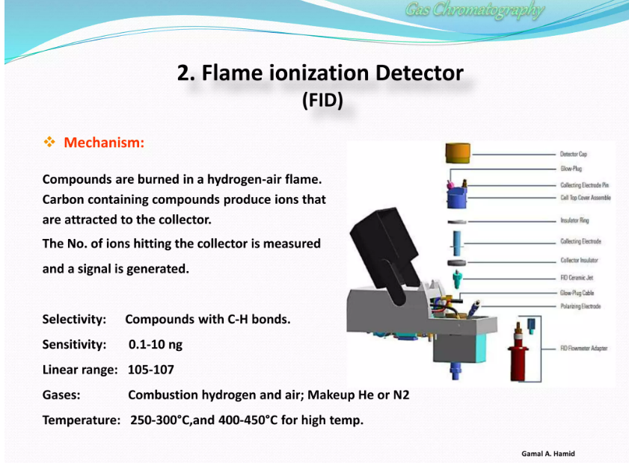



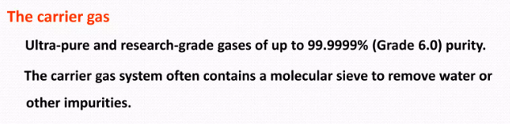

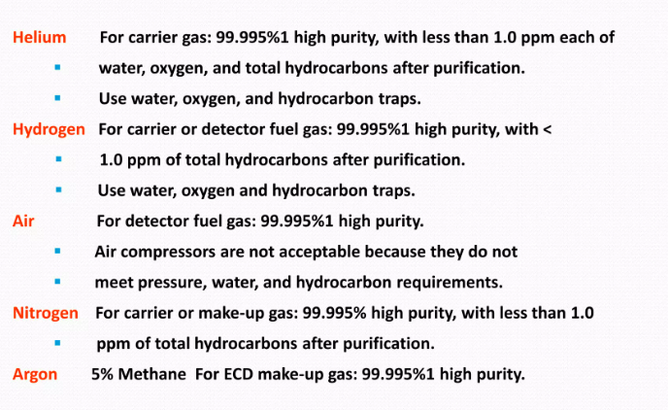

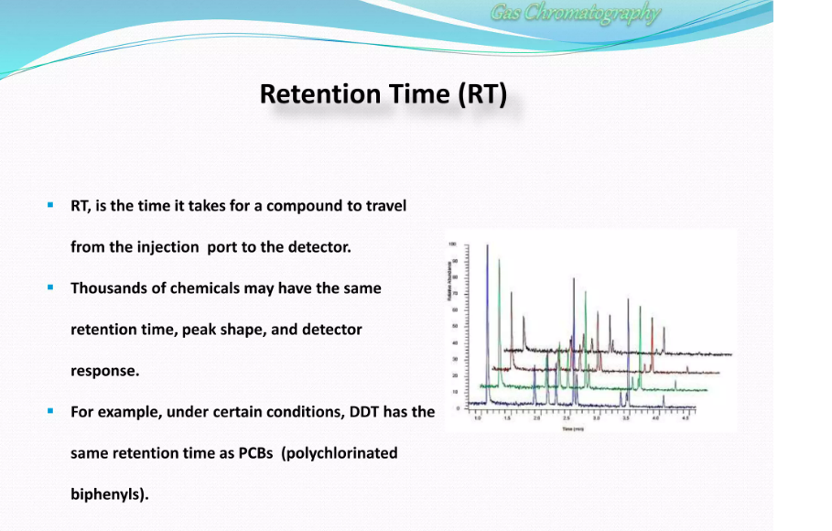

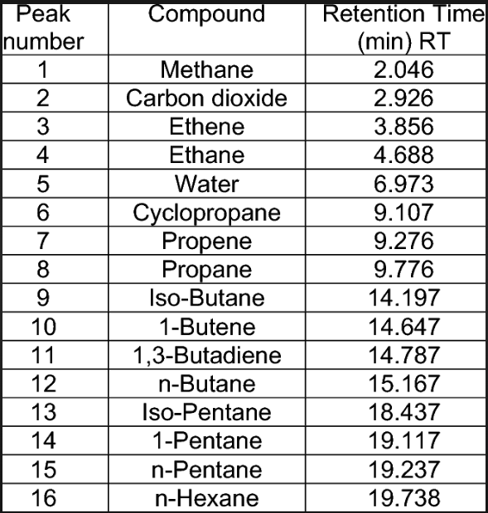

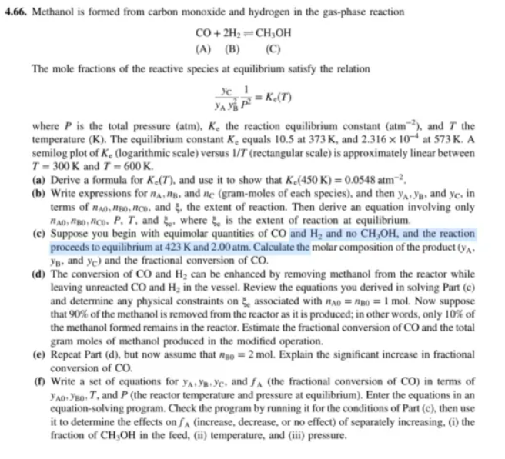

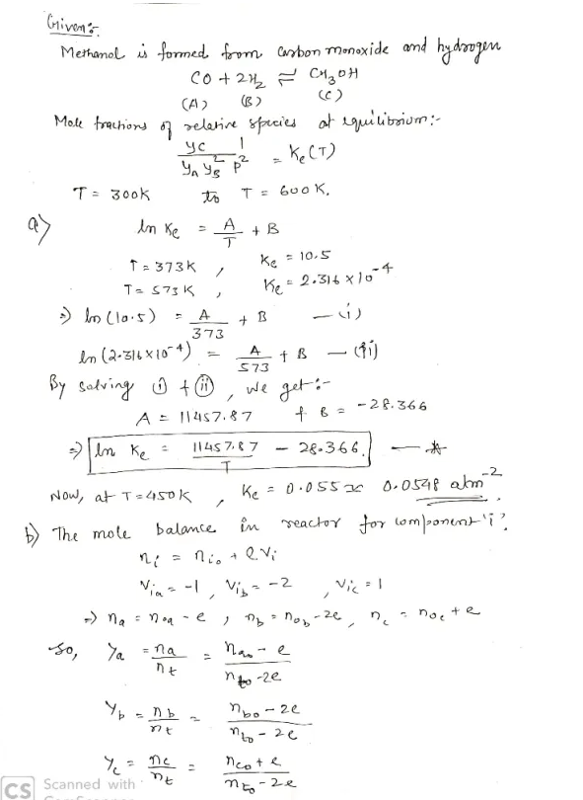

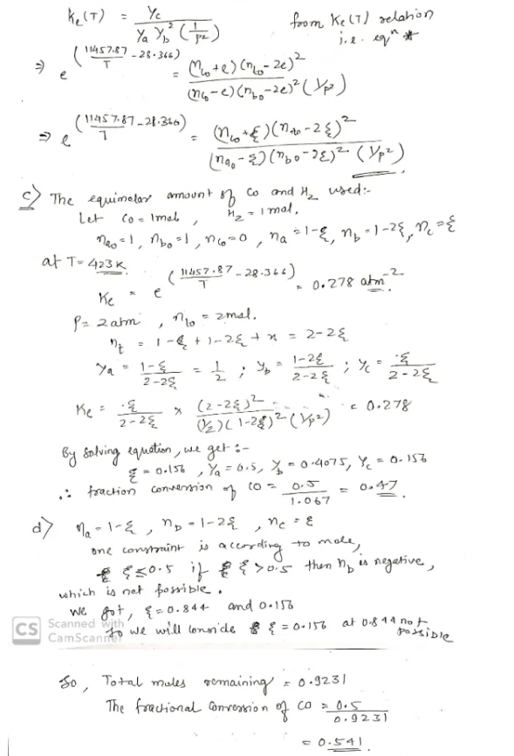

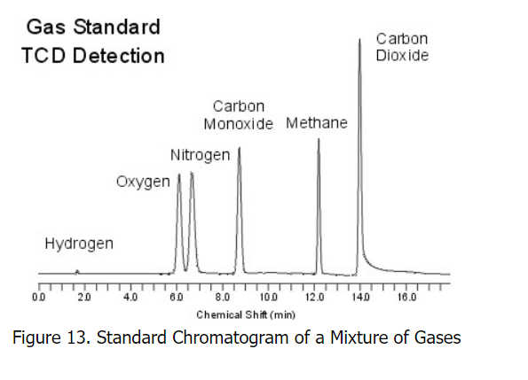

<https://chem.libretexts.org/Bookshelves/Analytical_Chemistry/Supplemental_Modules_(Analytical_Chemistry)/Instrumentation_and_Analysis/Chromatography/Gas_Chromatography>

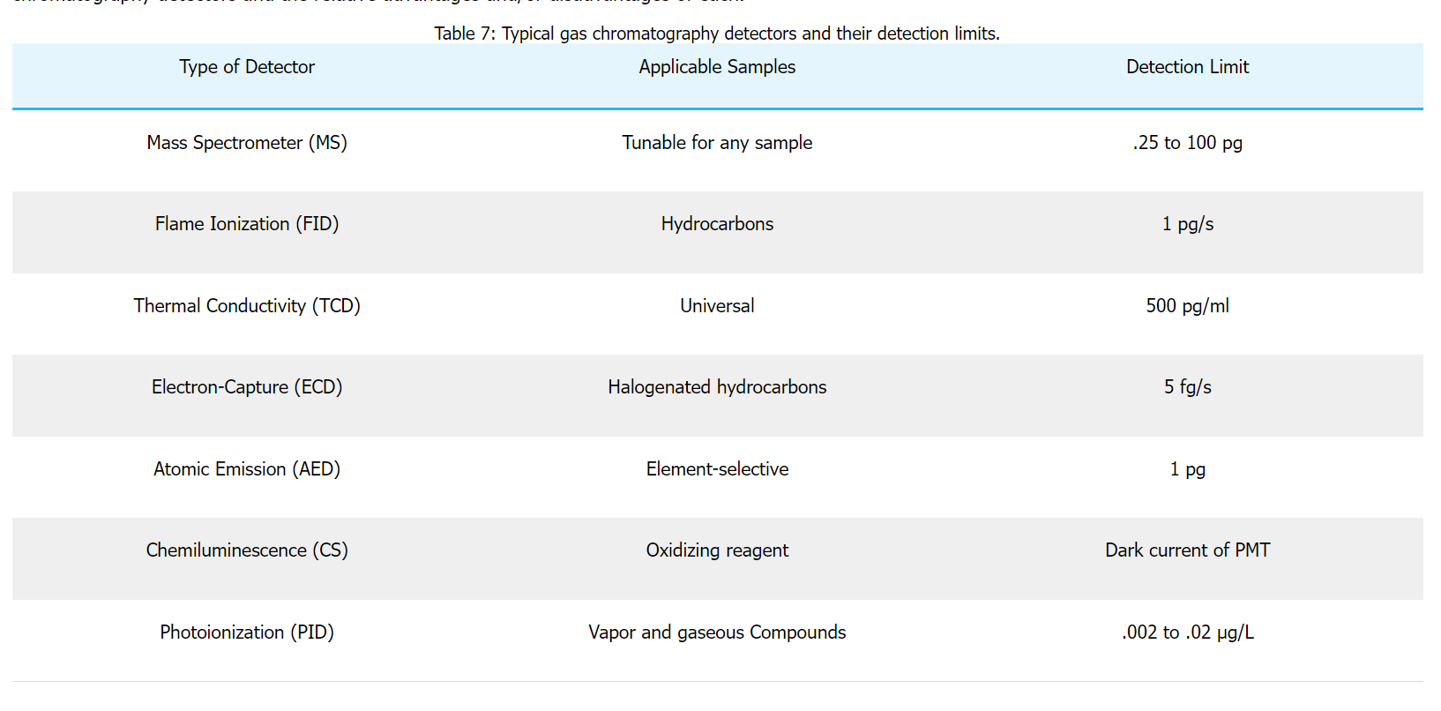

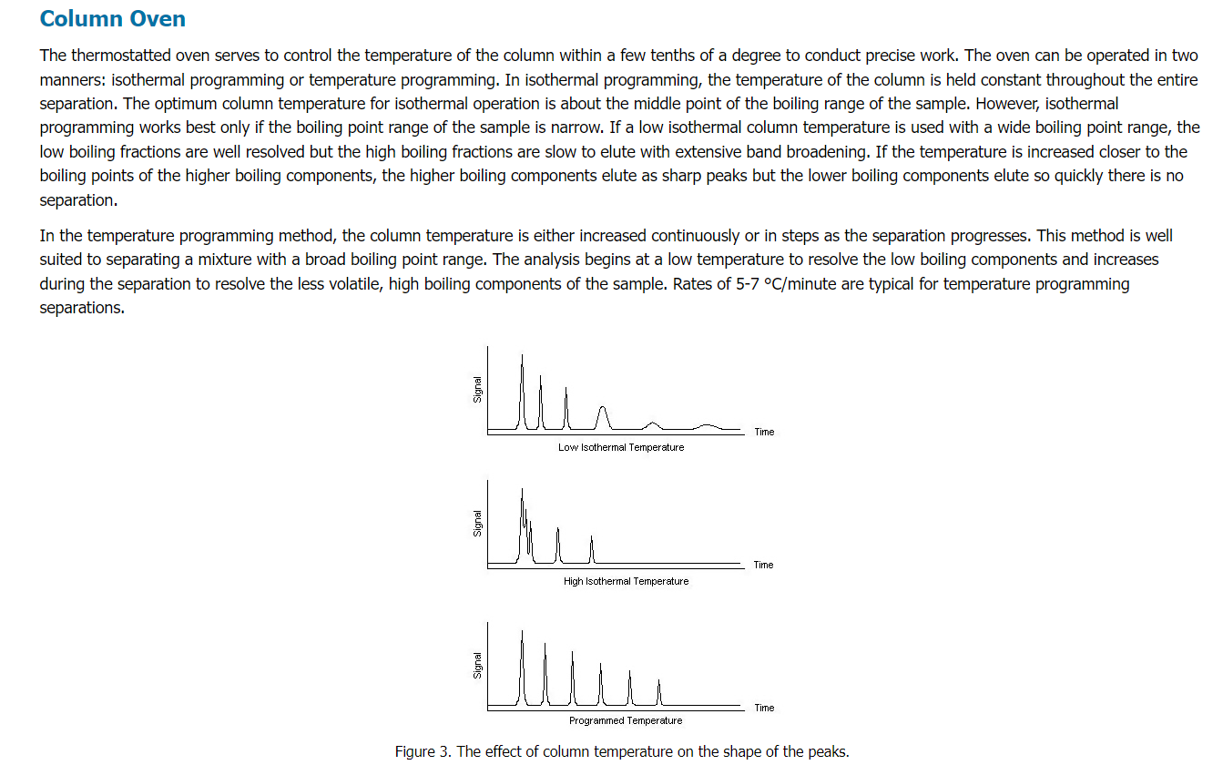

Methanizer is an appliance used in gas chromatography (GC), which allows the user to detect very low concentrations of carbon monoxide and carbon dioxide. It consists of a flame ionization detector, preceded by a hydrogenating reactor, which converts CO2 and CO into methane CH4.

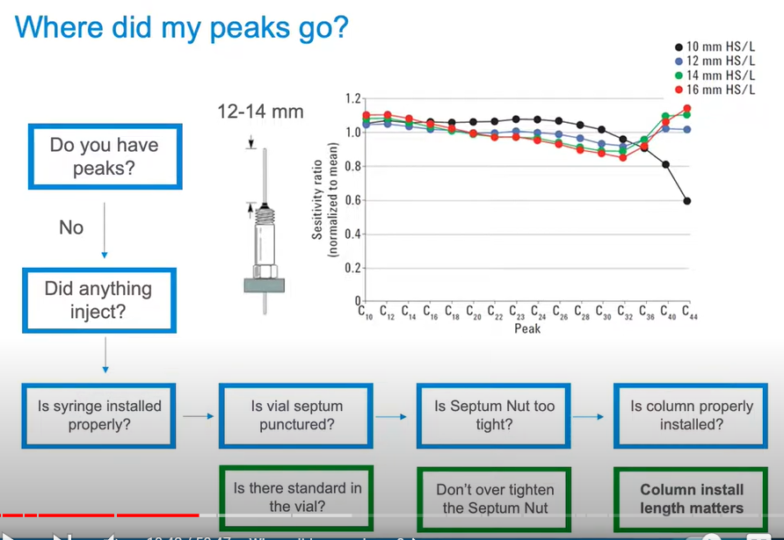

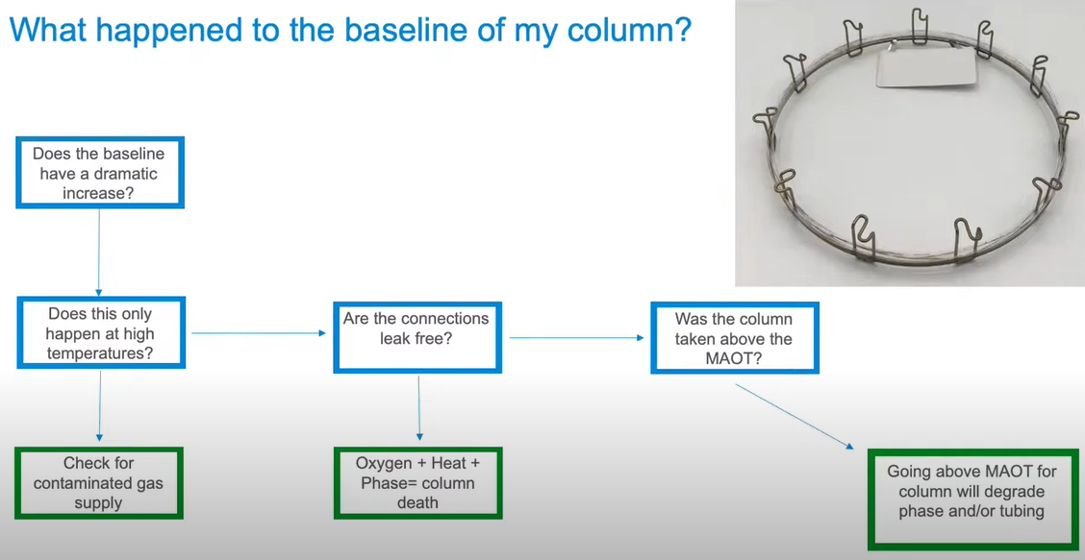

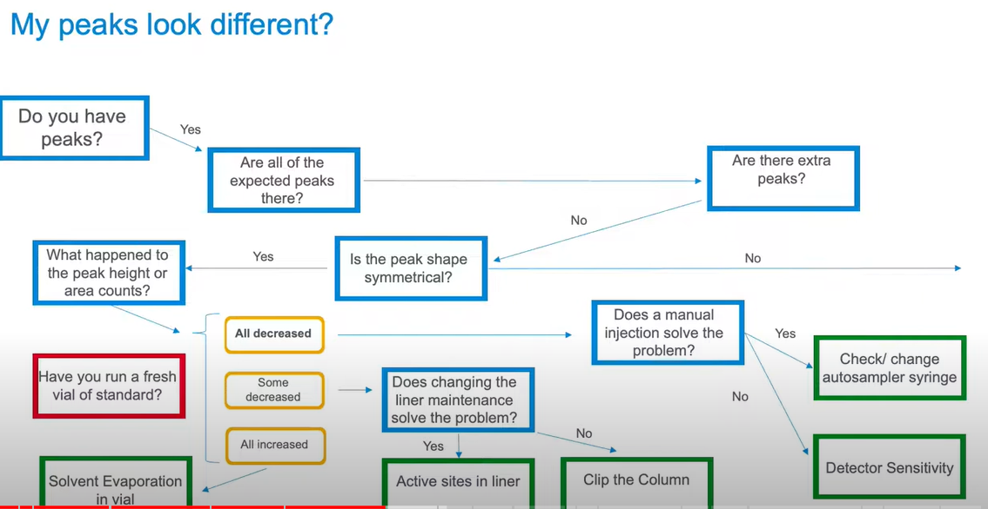

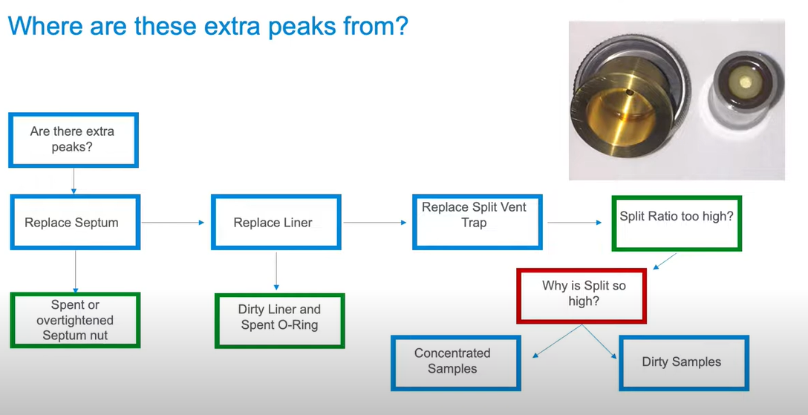

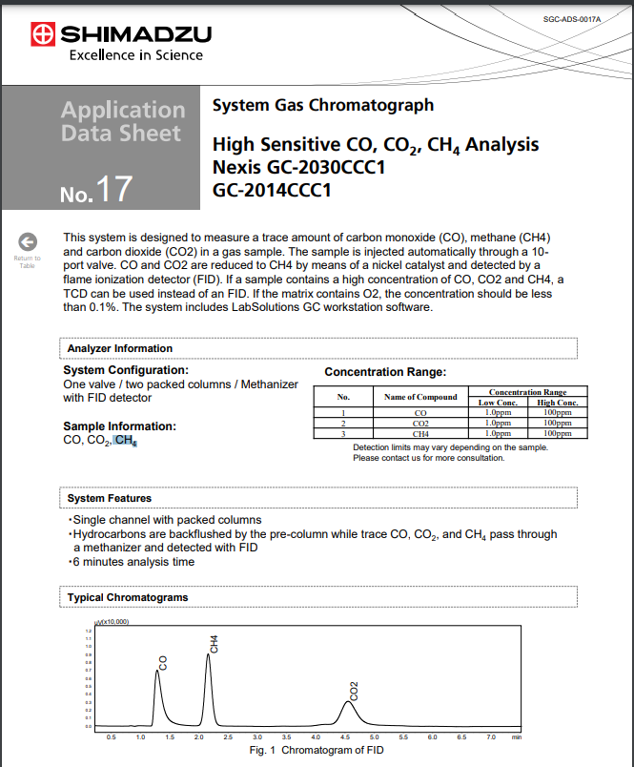

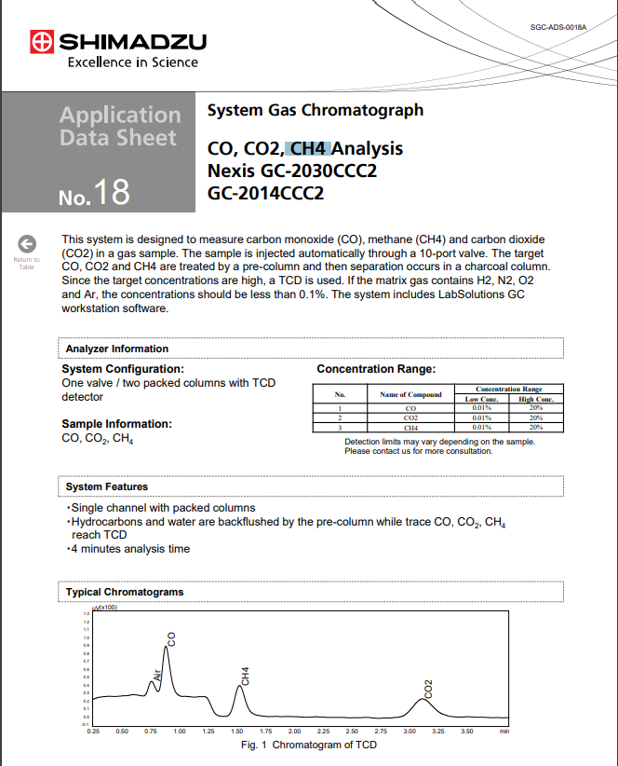

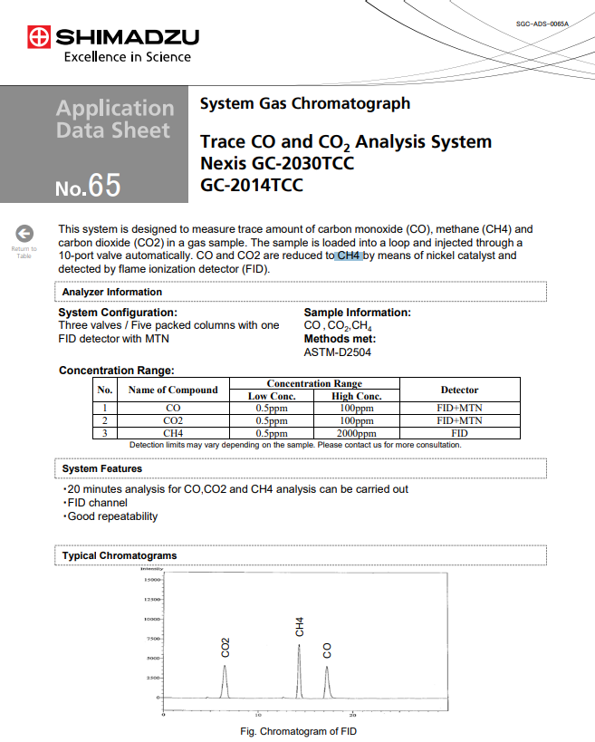

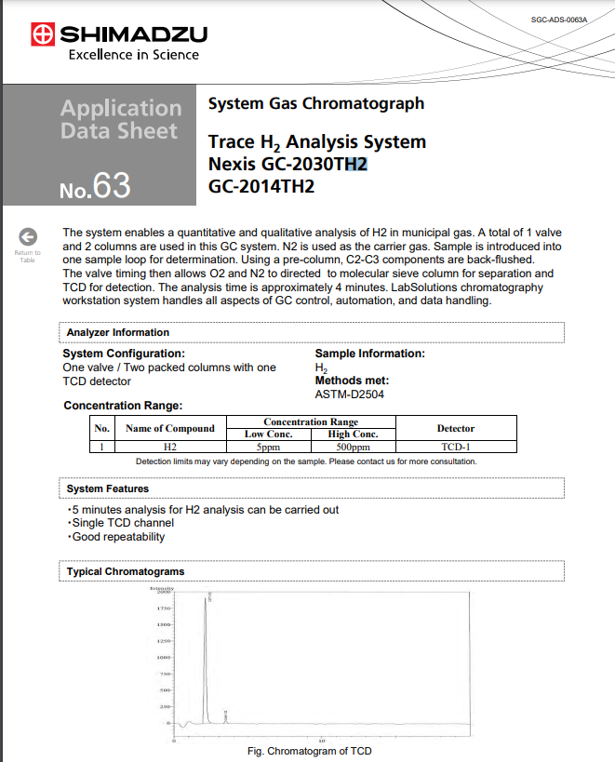

Example of the methanol reformer experiment:

<http://www.ccspublishing.org.cn/article/doi/10.1016/j.cclet.2017.03.038?pageType=en&viewType=HTML>

Standard Needed:

* Hydrogen
* Oxygen
* Carbon dioxide (50%) (1-100 ppm)
* Carbon monoxide (1-100 ppm)

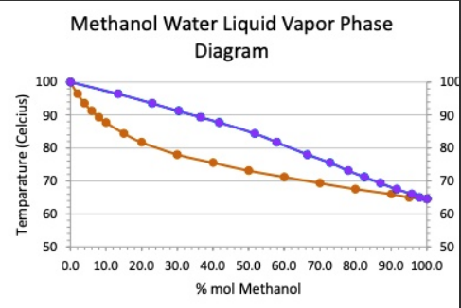

The boiling / vaporize temperature is above 80C for the 70% mol methanol.

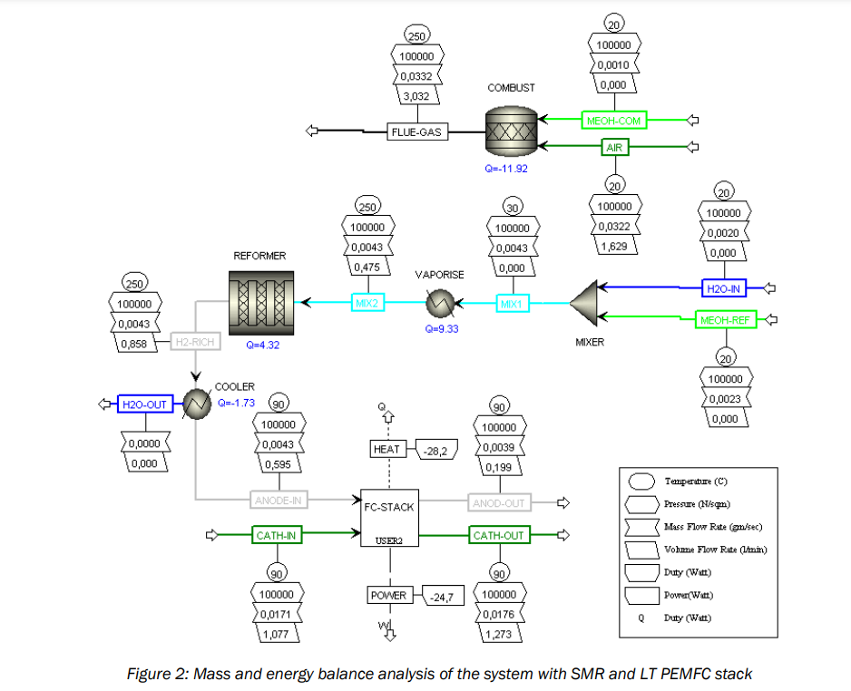

<https://www.mebius.si/docs/Mebius%20-%20Miltary%20Green%202012%20-%20Methanol%20Steam%20Reformer%20-%20HT%20PEMFC%20system%20analysis.pdf>

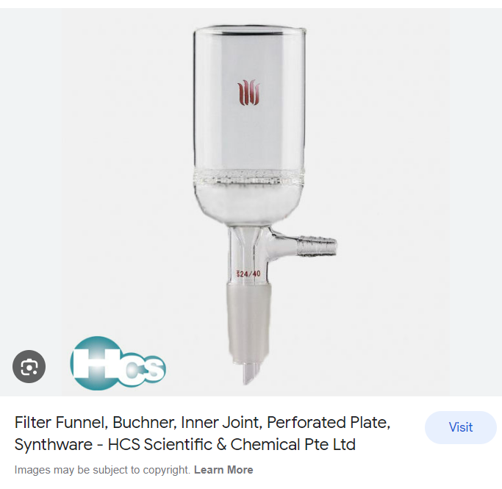

Sample preparation:

A typical concentration should be ~1-5 mg/mL for FID and GC/MS systems, and higher for TCD systems because they are less sensitive. The sample should never be injected in neat form! The GC samples cannot contain any solids. The injection port is very hot in order to allow for the solvent and the compounds evaporate instantaneously. The temperature of the injection port has to be ~10-20 oC above the boiling point ; The injection port is usually heated to 200-300 oC. The column temperature has to be above the dew points of the compounds to prevent condensation in the column. The temperature of the oven can be kept constant.

*Gas flow*  
  
A high carrier gas flow produces sharp peaks, but a poor separation. A very slow flow rate leads to significant peak broadening and causes a bad separation due to increased overlap of peaks. For a given problem, this parameter **has to be optimized** as well.

<https://www.chem.ucla.edu/~bacher/General/30BL/gc/practice.html#:~:text=A%20typical%20concentration%20should%20be,samples%20cannot%20contain%20any%20solids.&text=The%20sample%20solution%20is%20introduced,using%20a%20micro%2Dliter%20syringe>.

**โรส ศิรินทิพย์ - ความรัก (ประกอบละครกระเช้าสีดา)**

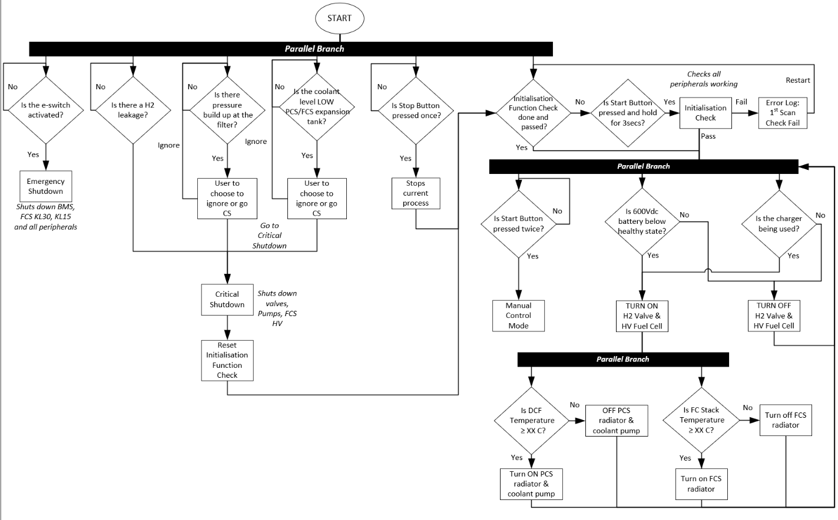

BIPOLAR FLOW DESIGN CHANNEL

1. SOURCE : <https://sci-hub.se/10.3390/app9173615>

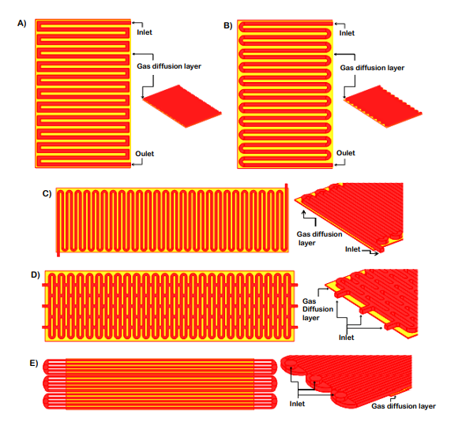

Design 1 VS 2:

* A very slow flow velocity appeared at the square corners when the flow changed direction abruptly (Design 1). Therefore, water could accumulate here, which would lead to uneven gas and current distributions.
* This figure shows that the electrical current decreased gradually along the y axis with the maximum value near the inlet. For example, when the distance was 4.4 cm, the total electrical current at 0.8 V was 27.28 mA in Design 1 and 27.69 mA in Design 2. The difference in the total electrical currents between the two designs was 1.48%.
* The serpentine square bends (Design 1) exhibited consistently higher pressure drops compared to the curvilinear bends used in Design 2. A large pressure drop leads to inefficient fuel cell performance

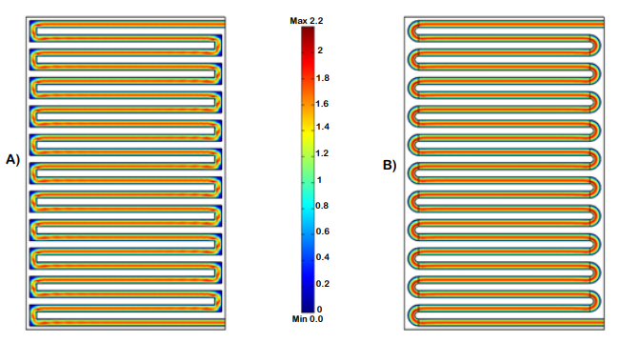

***From design 2, it was improved to make design 3,4,5

Design 3,4,5

* Mass oxygen fraction & Electrical current distributions (mA/cm2) at the cathode spotted for design 4 &5 are more uniform and have a higher result
* This can be explained because the intakes were efficiently located. Therefore, it was concluded that the effective placement of the intakes was as important as the shape of the channel configuration. The parallel channel flow field (Design 5) was the best alternative for current collectors due to its superior performance
* Q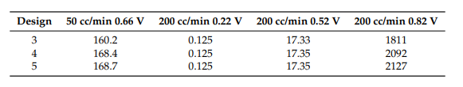

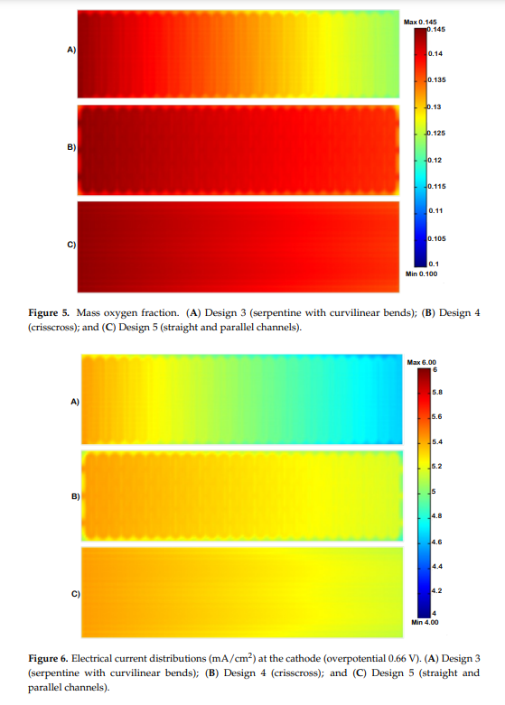

1. SOURCE : <https://sci-hub.se/https://doi.org/10.1016/j.jpowsour.2008.10.093>

Redesigning the cathode bipolar plate design

1. Original
2. Case A: the redesigned channel length equals 20 mm (from 30 to 50 mm)
3. Case B: the redesigned channel length equals 15 mm (from 35 to 50 mm)
4. Case C: the redesigned channel length equals 10 mm (from 40 to 50 mm)

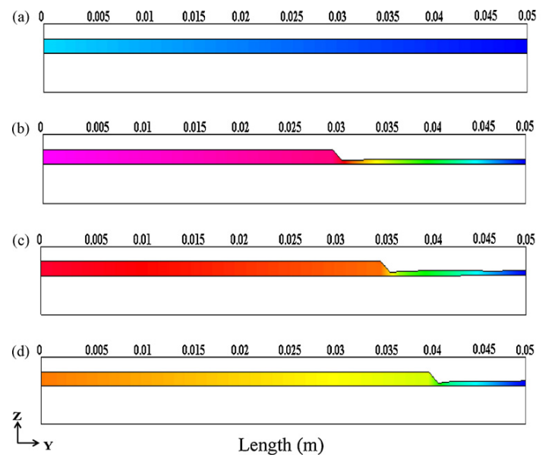

The side view of the gas channel

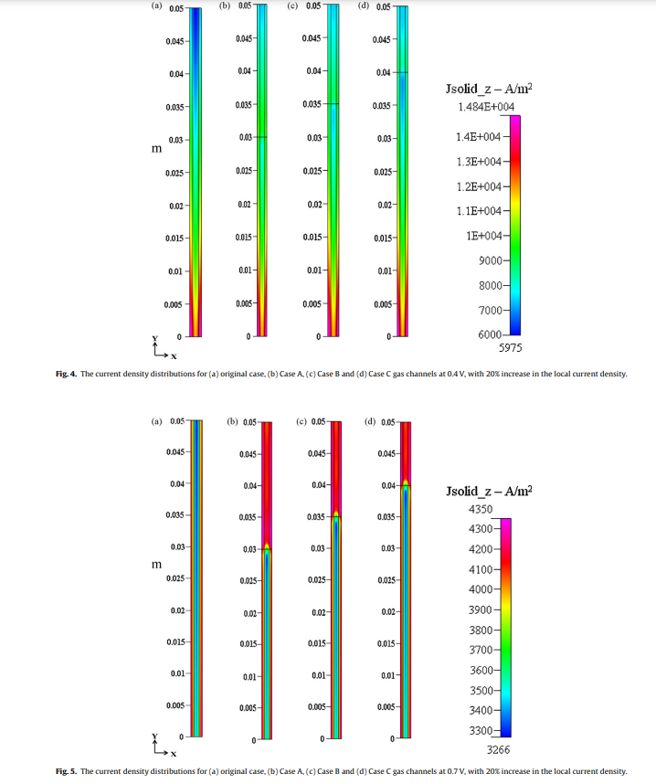

**It is obvious from these two figures that the current densities in the redesigned gas channels are all higher than those for the original gas channel.

**gas channel must be contracted suddenly at the start of the redesigned position of the gas channel, in order to remove the saturated water as well as to increase the concentration of oxygen.

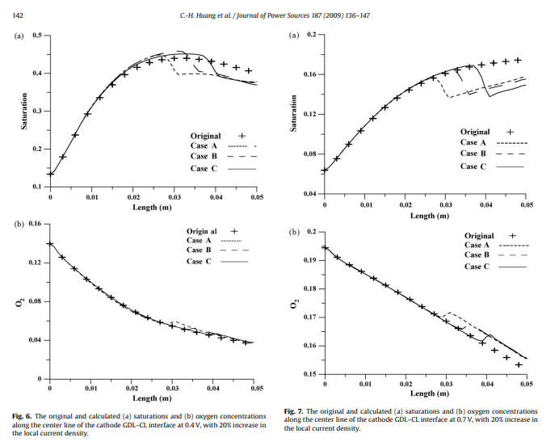

** the longer the redesigned channel, the more saturated water will be removed, and that the saturation at 0.4 V is more than that at 0.7 V. Contrarily, the oxygen concentration at 0.4 V is less than that at 0.7 V. This is because the electrochemical reaction is more moderate at 0.7 V than at 0.4 V, and as a result less oxygen will be consumed and less water will be produced at 0.7 V. This also explains why the overall increase of current at 0.4 V is higher than that at 0.7 V. From Figs. 6(b) and 7(b), at the redesigned position of the original gas channel, the oxygen concentration for 0.4 V is much lower than that for 0.7 V. This implies a perfect reaction at 0.4 V. By imposing the requirement that the redesigned current density be 20% greater than the original current density at the redesigned position, the amount of the increment of oxygen concentration at 0.4 V is also almost consumed when compared with the case at 0.7 V, and therefore the overall increase of current at 0.4 V is greater than that at 0.7 V.

|  |  |  |
| --- | --- | --- |
|  | 0.4V | 0.7V |
| Water Production | ↑ | ↓ |
| Oxygen Concentration | ↓ | ↑ |
| Oxygen Consumption | ↑ | ↓ |
| Current Generated | ↑ | ↓ |

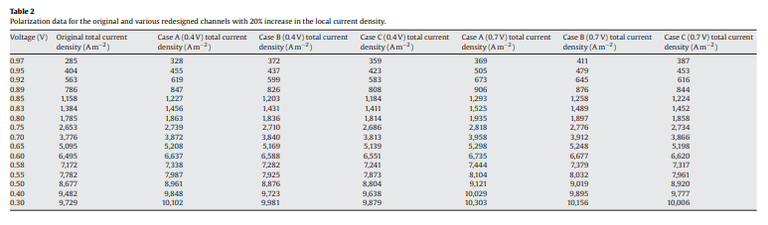

**The overall increased percentages for the current in these six cases are obtained as 3.9% (Case A at 0.4 V), 2.5% (Case B at 0.4 V), 1.6% (Case C at 0.4 V), 4.8% (Case A at 0.7 V), 3.6% (Case B at 0.7 V), and 2.4% (Case C at 0.7 V), respectively.

3. SOURCE: https://sci-hub.se/10.1016/j.jpowsour.2006.05.007

Title : Numerical study on cell performance and local transport phenomena of PEM fuel cells with novel flow field designs

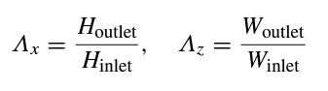

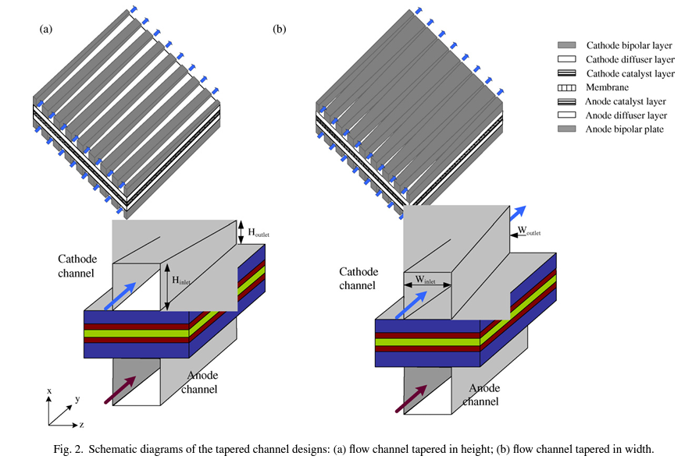

1. For the cathode channels tapered in height, the reduction in outlet height is beneficial to the fuel utilization efficiency and the improvement in the cell performance.

2. For the tapered channel with the width of flow channel enlarged along the flow, the contact area of the interface between channels and GDL increases, which in turn, results in an increase in the transport rate of fuel in the outlet. Therefore, the cell performance is improved.

3. The flow channels tapered in height can enhance the fuel velocity along the flow channel, and improve the liquid water removal, whose rate increases with the decrease in height taper ratio. For the design of width tapered flow channels, the rise of the width decelerates the flow and weakens the capability of liquid water removal, while it increases the reaction efficiency and cell performance. 4. At the height taper ratio Λx of 0.1, the design with a large width tapered ratio weakens the taper effect. Therefore, the cell performance, the fuel velocity and the efficiency of liquid water removal are all reduced as the width taper ratio increases.

5. If the power loss due to pressure drop is not considered, the performance of the fuel cell with the tapered flow channels is consistently improved with height taper ratios decreased and width taper ratio increased. With the pressure loss considered, however, the best performance can be obtained at the height taper ratio (Λx) of 0.5 and the width taper ratio (Λz) of 1.8 among the taper ratios studied in the present work.

|  |  |
| --- | --- |
| Tapered in height (Λx) | Tapered in width (Λz) |
| Reduction in the outlet height better, fuel utilization and performance | Increase in the width better, increase in the contact area of channels and GDL |
| improve the liquid water removal and the velocity flow distribution | decelerates the flow and weakens the capability of liquid water removal |
| With the pressure loss considered, the best performance can be obtained at the height taper ratio (Λx) of 0.5 | With the pressure loss considered the best performance can be obtained at the width taper ratio (Λz) of 1.8 |
| Reduction in height and increment in width, performance and efficiency decrease as the width taper ratio increases | |

4. SOURCE : <https://sci-hub.se/10.1016/j.rser.2019.04.081>

TITLE : A comprehensive study of the effect of bipolar plate (BP) geometry design on the performance of proton exchange membrane (PEM) fuel cells

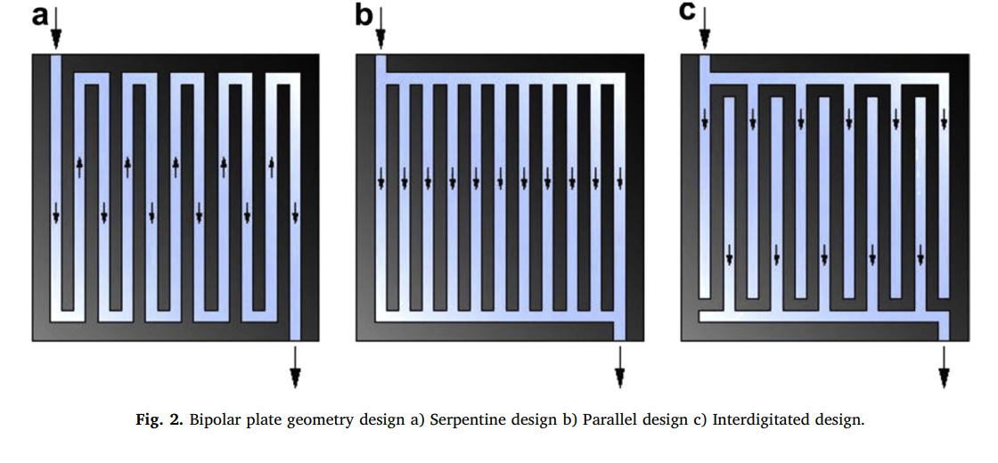

|  |  |  |
| --- | --- | --- |
| Serpentine design | Parallel design | Interdigitated design |
| uneven gas distribution | fewer drops in pressure | easy removal of water |
| good flooding management, thermal conductivity. |  | increased the convection & efficiency |
| The electrochemical reaction for the serpentine bipolar plate design increased with respect to the number of channel arms, length of the channel and the channel number. |  | overall fuel consumed when the bipolar plate geometry design is interdigitated is less than that of the parallel design  Possible long-term damage to GDL |

|  |  |
| --- | --- |
|  |  |
| Pin design | Cascade design |
| Low pressure drop, water arrangement issue, thermal distribution issue, gas distribution issue | gas flow rates and pressure drop constant, low rate of reactant penetration |

The second part of the study (choose the best design from each study):

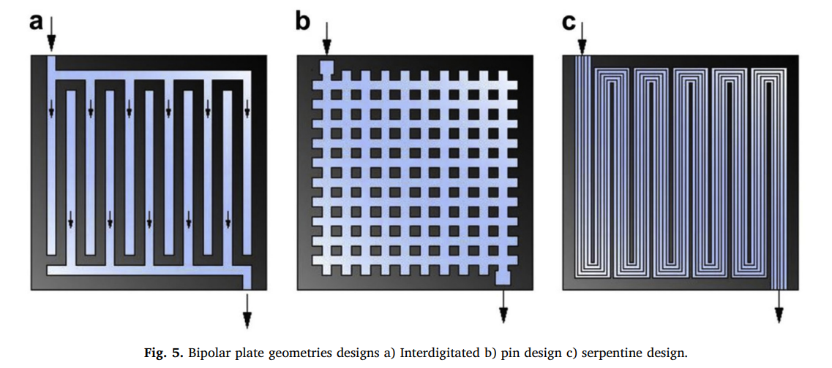

|  |  |  |
| --- | --- | --- |
| Interdigitated design | Pin design | Serpentine Design |
| Interdigitated design give out the best performance out of these 3.  There is even distribution of the reactants for the serpentine and interdigitated bipolar plate design across the entire surface of the catalyst layer thus enhancing the efficiency of the cell. | | |
|  |  |  |
|  |  |  |

|  |  |
| --- | --- |
|  |  |
|  |  |
|  |  |

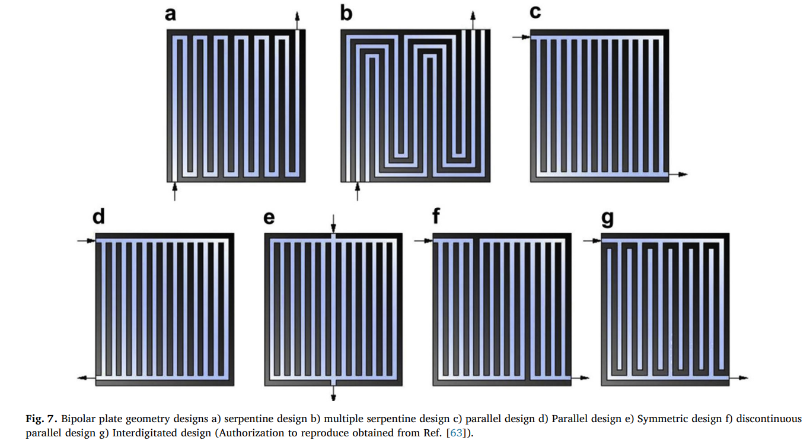

*** when the bipolar plate geometry has large active area, the reactants that flow through the channels are low.

*** channel depths of 200, 400 and 600 μm on PEM fuel cell performance. The fuel cell performance with channel depth 200 μm was worse - f insufficient reaction time because of the fast flow velocity. 400 μm channel depth performance was the best

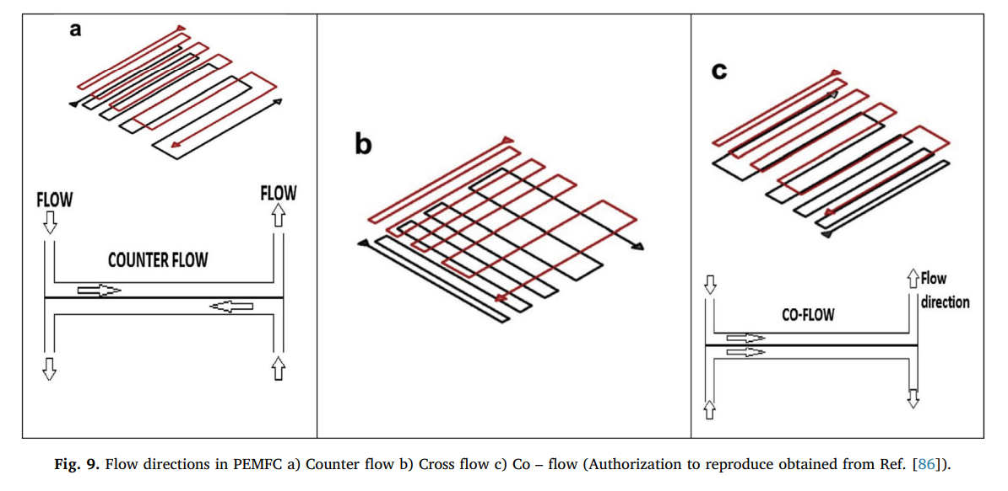

* cell efficiency using counter flow orientation was greater than other flow directions and this is because the gas was well humidified and evenly distributed in the cell.
* Rib depth 1.8 mm performed better even at high voltage and a low amount of fuel gas consumption

1. SOURCE: <https://sci-hub.se/https://doi.org/10.1016/j.enconman.2016.10.053>

TITLE : Flow field bipolar plates in a proton exchange membrane fuel cell: Analysis & modelling

Land-To-Channel Ratio

** channel width should be kept under 1.5 mm to maintain mechanical stability

** land-to-channel ratio should be kept as low as possible to minimize voltage losses. recommends a land-to-channel ratio between 1 and 2 for optimum performance.

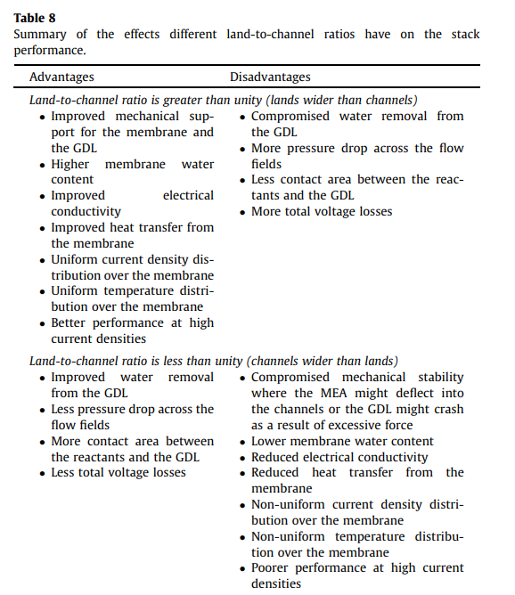

Shape Of the Channels

* circular channels promote the formation of a continuous film of water
* tapered channels promote the formation of discontinuous water droplets

1. SOURCE : https://sci-hub.se/https://doi.org/10.1016/j.ijhydene.2017.12.149

TITLE : Numerical optimization of channel to land width ratio for PEM fuel cell

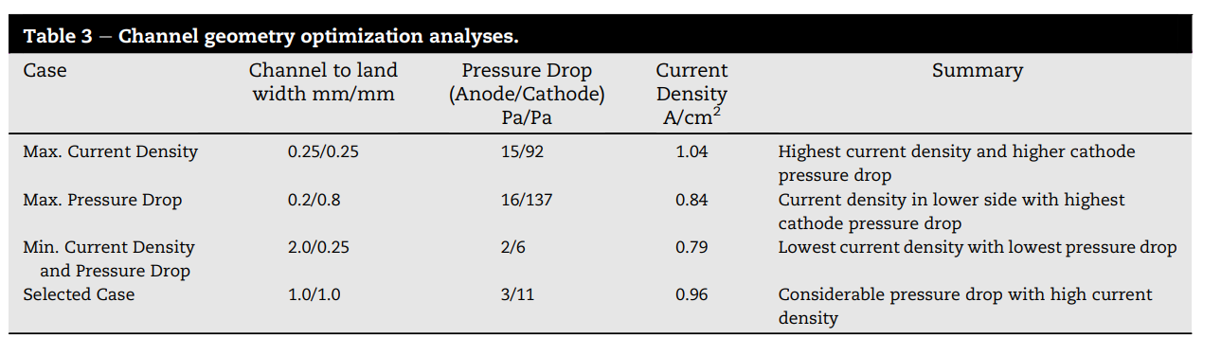

* effect of channel width has more impact on pressure drop than land width.
* minimum the channel width, the maximum the pressure drop is.
* pressure drop is too high which will reduce the overall cell efficiency.
* e channel to land width of 1.0 mm/1.0 mm would provide the best cell performance having a cell current density of 0.96 A/cm2 and 3 Pa/11 Pa for anode/cathode pressure drop.

1. SOURCE: chrome-extension://efaidnbmnnnibpcajpcglclefindmkaj/http://electrochemsci.org/papers/vol17/220319.pdf

TITLE : Effect of flow channel shapes of proton exchange membrane fuel Cell on its performances

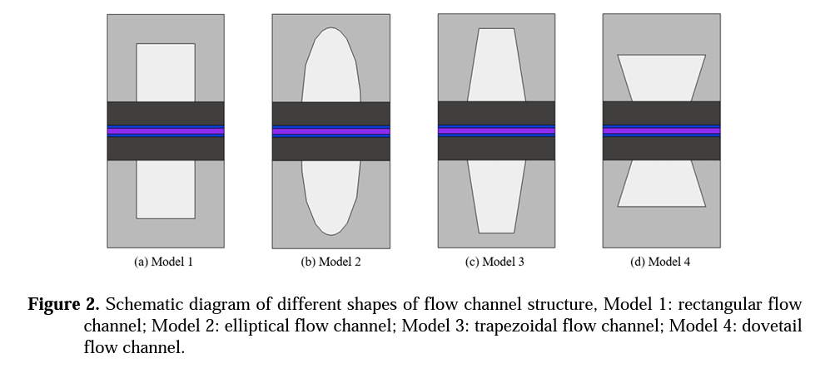

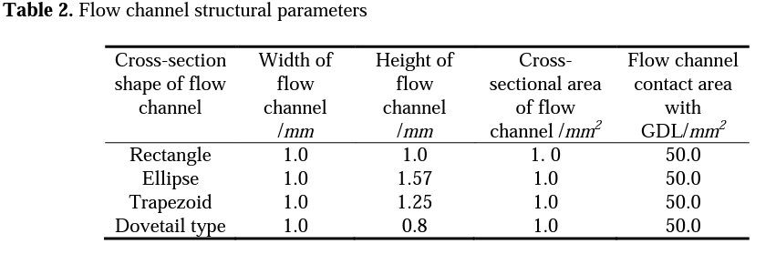

**Model 4 : best polarization performance, uniform oxygen distribution, better water removal effect, higher current density distribution, optimal thermal distribution

**Model 1 : better water removal effect

SOURCE : https://sci-hub.se/https://doi.org/10.1016/j.ijheatmasstransfer.2018.10.050

TITLE : Flow field plates with trap-shape channels to enhance power density of polymer electrolyte membrane fuel cells

* A channel with the optimum number (two) and length (8 mm) of traps in maximum current, power densities, uniform oxygen mass fraction, uniform water mass and thermal fraction / distribution.

RECOMMENDATION

Land-To-Channel Ratio (SOURCE 6)

|  |  |
| --- | --- |
| Current | Recommend |
| Land : Channel = 0.8 : 0.6 | Land : Channel = 1.0 : 1.0 OR 0.8:0.8 |
| Land-to-channel ratio is greater than unity | Land-to-channel ratio is unity |

* increase the channel width to ensure increase contact area between the reactants and the GDL

Shape Of the Channels (SOURCE 7)

|  |  |
| --- | --- |
| Current | Recommend |
| GDL-CCM | GDL-CCM |
| Rectangular flow channel | dovetail flow channel |

* better polarization performance, uniform oxygen distribution, better water removal effect, higher current density distribution, optimal thermal distribution